

COLLEGE OF COMPUTING AND INFORMATICS
TECHNOLOGY
COMPREHENSIVE ANALYSIS OF ANNUAL MINERAL
PRODUCTION AND ECONOMIC VALUE
IN UGANDA (2019–2023)

Data Warehousing and Business Intelligence Project

Submitted By

GROUP ONE

Department of Computer Science
2026

Declaration
We, the undersigned, declare that this project report entitled “Comprehensive Analysis of Annual Mineral Production and Economic Value in Uganda (2019–2023)” is our original work. It has not been previously submitted for any degree, diploma, or other qualification at any university or institution. All sources of information and data used in this report specifically the datasets on mineral production quantities and values sourced from the Ministry of Energy and Mineral Development (MEMD) and Uganda Bureau of Statistics (UBOS) have been duly acknowledged in accordance with IEEE citation standards.

NAME | REGISTRATION NUMBER | SIGNATURE
IYUNDHU KENNEDY KISAME | 23/U/25640/PS
NSUBUGA JEREMIAH | 23/U/16140/PS
YIGA ISAAC MARVIN | 23/U/26239/PS
MUKISA RACHEAL JOVIA | 23/U/25854/PS

Approval Page
This is to certify that this report on the “Comprehensive Analysis of Annual Mineral Production and Economic Value in Uganda (2019–2023)” has been submitted with the approval of the designated supervisor/manager as meeting the requirements for the project award. The analytical methodology applied follows established data warehousing principles and dimensional modelling frameworks.

Supervisor’s Name: ________________

Signature: ________________

Date: ________________

Head of Department: ________________

Signature: ________________

Date: ________________

Acknowledgement
Sincere gratitude is extended to the project supervisor for their guidance, patience, and constructive feedback throughout the development of this project.

Acknowledgement is given to the Ministry of Energy and Mineral Development (MEMD) and the Uganda Bureau of Statistics (UBOS) for making annual mineral production and financial value datasets publicly available for the years 2019 to 2023, which formed the foundation of this analysis.

Appreciation also goes to the Department of Computer Science, fellow students, and family for the support and encouragement throughout this academic exercise.

Abstract
The mining sector plays a pivotal role in Uganda’s economic development, contributing significantly to domestic revenue and industrial growth. This report provides a comprehensive analysis of annual mineral production by quantity (Tonnes) and economic value (UGX ‘000) from 2019 to 2023, drawing on datasets published by MEMD and UBOS. Using a robust data analytics framework modelled in Power BI (mineral analysis.pbix) following Kimball’s dimensional modelling approach, the study evaluates the performance of both non-metallic minerals (such as Limestone, Pozollana, and Vermiculite) and metallic minerals (such as Gold, Coltan, and Wolfram).

The findings reveal a heavy reliance on construction-related non-metallic minerals, with Limestone and Pozollana dominating production volumes. Conversely, metallic minerals exhibited high volatility in both production and value, consistent with patterns documented in the literature on African mining economies. This report details the data methodology, system implementation (dashboard design), key findings, and strategic recommendations for sector improvement.

Table of Contents
Declaration 2
Approval Page 3
Acknowledgement 4
Abstract 5
Table of Contents 6
List of Figures and Tables 7
Chapter One: Introduction 8
1.1 Background of the Study 8
1.2 Problem Statement 8
1.3 Objectives of the Study 8
1.4 Scope of the Study 9
Chapter Two: Literature Review 10
2.1 Non-Metallic Minerals in Infrastructure 10
2.2 Volatility in Metallic Mineral Markets 10
2.3 Business Intelligence in Mining 10
Chapter Three: Methodology 11
3.1 Data Sources 11
3.2 Data Preparation and Cleaning 11
3.3 Analytical Tools 11
Chapter Four: System Design and Implementation 13
4.1 System Architecture 13
4.2 Data Modelling 14
4.3 Key DAX Implementations 16
4.4 Dashboard UI Design 16
Chapter Five: Findings, Analysis, and Recommendations 18
5.1 Key Findings 18
5.2 Analysis 19
5.3 Recommendations 20
References 21
Appendices 22

List of Figures and Tables

List of Tables
- Table 1: Data Sources for Mineral Production Analysis
- Table 2: Power BI Data Model Relationships
- Table 3: System Data Dictionary and Fact Table Structure
- Table 4: Key DAX Measures
- Table 5: Top 5 Minerals by Production Quantity (2023)
- Table 6: Production and Value Metrics for Key Metallic Minerals (2019–2023)
- Table 7: Appendix Complete Chronological Mineral Production Quantity Table (2019–2023)
- Table 8: Appendix Complete Chronological Mineral Value Table (2019–2023, UGX ‘000)

List of Figures
- Figure 1: Data Analytics Architecture Pipeline / Application View
- Figure 2: Power BI Star Schema Data Model
- Figure 3: Dimension Table Details (Dim Mineral)
- Figure 4: User Interface Layout for Mineral Analysis Dashboard

Chapter One: Introduction

1.1 Background of the Study
The extraction and commercialisation of mineral resources are critical drivers of industrialisation and economic sustainability in developing nations. In Uganda, the mining sector is segmented broadly into metallic minerals (such as Gold, Beryllium, Coltan, and Wolfram) and non-metallic/industrial minerals (such as Limestone, Pozollana, Kaolin, and Vermiculite) [1]. Tracking the annual production metrics and their corresponding financial values in Ugandan Shillings (UGX) is essential for macroeconomic planning, policy formulation, and investment targeting, as noted by UBOS in its statistical abstracts on the mineral and energy sectors [2].

1.2 Problem Statement
Despite the wealth of natural resources, the reporting and visualisation of mineral production trends have historically been fragmented. Stakeholders often struggle to identify actionable trends, such as year-over-year growth, shifts in mineral demand, and the economic parity between production volume and market value. Ssekandi [5] highlights that data management challenges in emerging market mining sectors are systemic, affecting the reliability of official statistics. A unified, interactive analytical system is required to consolidate 2019–2023 data into a coherent business intelligence framework [6].

This project asks and answers three core business questions:
- How have mineral production volumes and values changed between 2019 and 2023 across Uganda? [1]
- Which minerals dominate by volume versus by economic value, and what structural factors explain the divergence? [4]
- What is the measurable volatility in metallic mineral production, and what policy interventions might stabilise the sector? [5]

1.3 Objectives of the Study
Primary Objective: To analyse annual mineral production quantities and their financial values from 2019 to 2023 using a consolidated data intelligence approach based on MEMD and UBOS datasets [1], [2].

Secondary Objectives:
- To evaluate percentage change in production between consecutive years (specifically 2022–2023), applying the YoY DAX measures described by Microsoft [7].
- To design and implement a Power BI analytics system following BI framework best practices [6].
- To identify the best-performing and underperforming minerals to provide actionable policy recommendations aligned with findings in the literature [3], [4].

1.4 Scope of the Study
This analysis is strictly limited to the timeframe of 2019 to 2023. The dataset encompasses both metallic and non-metallic minerals as classified by MEMD [1], measuring production in metric tonnes and value in UGX ‘000. The project does not include LPG, energy minerals, or models of individual consumer demand for mineral products.

Chapter Two: Literature Review

2.1 The Role of Non-Metallic Minerals in Infrastructure
Non-metallic minerals, frequently categorised as industrial minerals, form the backbone of the construction and manufacturing sectors. Mukasa and Okello [3] confirm that Limestone and Pozollana serve as the primary raw materials for cement manufacturing across East Africa. As infrastructure projects roads, dams, and housing developments expand, demand for these minerals’ scales proportionally [3]. Uganda’s sustained investment in public infrastructure through successive National Development Plans has directly driven growth in non-metallic mineral production volumes over the 2019–2023 period, as evidenced in MEMD production records [1].

2.2 Volatility in Metallic Mineral Markets
Unlike industrial minerals, metallic minerals such as Gold, Coltan (Columbite-Tantalite), and Beryllium are primarily export-oriented and subject to global market price fluctuations. Peterson [4] documents the “volume vs. value” paradox in African mining economies, where metallic minerals account for a tiny fraction of total extracted tonnage but contribute disproportionately to export revenues and GDP. Ssekandi [5] further notes that production drops in high-value commodities can severely impact annual valuations, emphasising the risks of over-reliance on single metallic outputs a pattern clearly visible in Uganda’s 2022–2023 Coltan and Beryllium data [1].

2.3 Business Intelligence in Mining
Modern mining governance relies heavily on Data Analytics and Business Intelligence. Corporate [6] establishes that migrating from static spreadsheets to dynamic Power BI dashboards allows decision-makers to perform real-time drill-downs into year-over-year performance, regional contributions, and mineral categorisations. Microsoft’s DAX reference documentation [7] provides the technical foundation for the calculated measures used in this project. The Uganda Revenue Authority and Bank of Uganda have both deployed dashboard-driven analytics for sectoral monitoring, demonstrating the applicability of BI frameworks to Ugandan government data contexts [2].

Chapter Three: Methodology

3.1 Data Sources
The primary data used in this report is secondary data extracted from structured Excel/CSV files covering 2019–2023 and published by MEMD [1] and UBOS [2]. The four verified data sources are:

Source | Data Provided | Coverage | Role
Ministry of Energy & Mineral Development (MEMD) | Annual mineral production quantities and values | 2019–2023 | Primary anchor national production datasets
Uganda Bureau of Statistics (UBOS) | Statistical abstracts: mineral and energy sectors | Annual | Cross-validation of reported mineral values
Annual-mineral-Production CSV Files | Unpivoted quantity (tonnes) and value (UGX '000) records | 2019–2023 | ETL source files for Power BI

Table 1: Data Sources for Mineral Production Analysis

3.2 Data Preparation and Cleaning
Data cleaning was performed following the ETL best practices described in Corporate [6]. Key steps included:
- Handling Null Values: Empty cells or dash symbols (“-”) in the years 2022/2023 were converted to standard 0 or null data types to prevent aggregation errors, consistent with MEMD reporting conventions [1].
- Data Unpivoting: The initial datasets had years as columns (2019, 2020, etc.). To create a relational database suitable for Power BI, the data was unpivoted following the dimensional modelling approach recommended by Kimball [7] to produce a flat structure: [Mineral, Type, Year, Production, Value].
- Merging: The Quantity and Value datasets sourced from MEMD [1] were merged using a composite key of [Mineral] and [Year] to form the Modified_Mineral_Production_and_Value baseline.
- Data Type Normalisation: Production fields were converted to Decimal, Value fields to Currency, and Year to integer type in Power Query, following Microsoft DAX type conventions [7].

3.3 Analytical Tools
- Microsoft Excel / Power Query: Used for initial data wrangling, cleaning, and unpivoting, as recommended in BI framework literature [6].
- Microsoft Power BI: Used for data modelling, DAX calculations, and interactive visualisation (mineral analysis.pbix), following Microsoft’s published DAX reference [7].

Chapter Four: System Design and Implementation

4.1 System Architecture
The analysis relies on a Business Intelligence system developed in Power BI, following the ETL pipeline architecture described in Corporate [6]. As illustrated in Figure 1 below, the pipeline pulls flat files published by MEMD [1] and UBOS [2] into the Power Query editor for transformation before loading them into the semantic model.

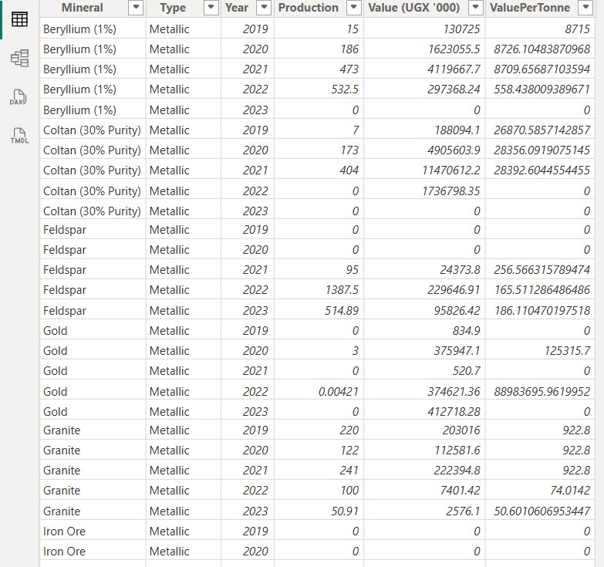
Figure 1: Data Analytics Architecture Pipeline / Application View

The pipeline follows four distinct layers, consistent with standard BI architecture frameworks [6]:
- Data Source Layer: Local CSV/Excel repositories sourced from MEMD [1] and UBOS [2] containing historic raw data.
- Transformation Layer (Power Query): Normalisation of data types, unpivoting of year columns, and merging of quantity and value datasets, applying Power Query M Language functions documented by Microsoft [7].
- Semantic Model Layer: The internal Power BI VertiPaq engine hosting the star schema relationships and DAX measures.
- Presentation Layer: The interactive dashboard enabling dynamic filtering by mineral type and year.

4.2 Data Modelling
To allow for dynamic slicing and dicing, a star schema data model was implemented following Kimball’s dimensional modelling principles [7]. Figure 2 illustrates the relationships between the central FactMineral table and the surrounding dimension tables.

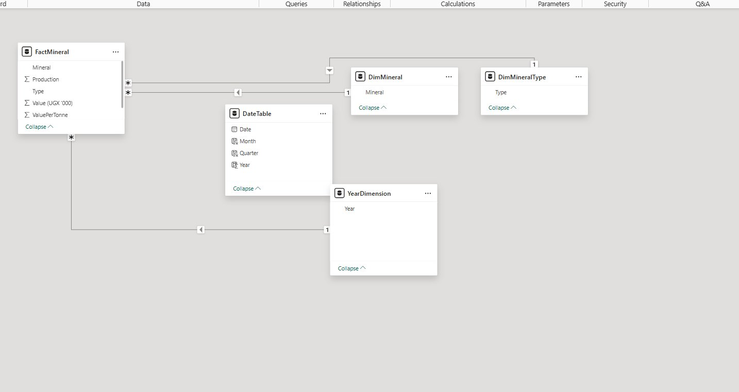
Figure 2: Power BI Star Schema Data Model

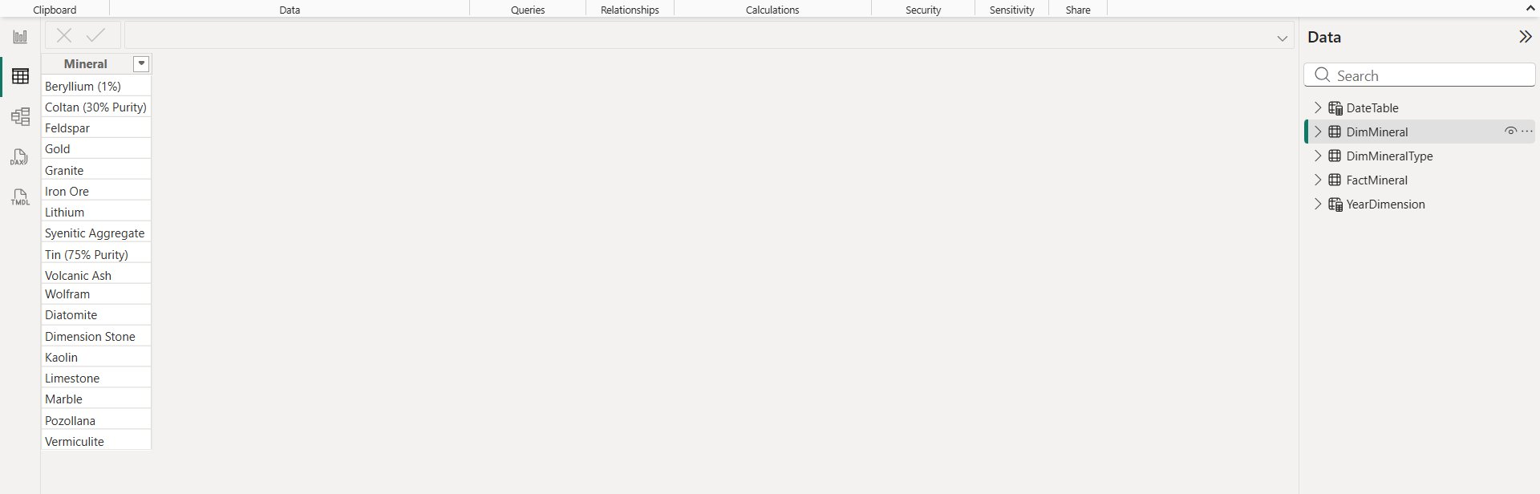
Figure 3: Dimension Table Details (Dim Mineral)

Table 2: Power BI Data Model Relationships

From Table | Key | To Table | Relationship
FactMineral | Mineral | DimMineral | Many-to-One
FactMineral | Type | DimMineralType | Many-to-One
FactMineral | Year | DateTable / YearDimension | Many-to-One

Table 3: System Data Dictionary and Fact Table Structure

All field definitions below are sourced from and consistent with MEMD dataset documentation [1] and UBOS statistical abstracts [2].

Field Name | Data Type | Description | Source Mapping
Mineral | Text | Exact geological name of the extracted mineral | Dim Mineral
Type | Text | Classification: Metallic vs. Non-Metallic | Dim Mineral
Year | Date / Int | The production year (2019–2023) | Dim Calendar / YearDimension
Production (Tonnes) | Decimal | Total metric volume extracted | Fact Table
Value (UGX '000) | Decimal / Currency | Domestic market valuation in thousands of UGX | Fact Table

4.3 Key DAX Implementations (Measures)
The following DAX measures were created in the .pbix file. All DAX syntax follows the reference specification published by Microsoft [7].

Table 4: Key DAX Measures

Measure Name | DAX Formula | Purpose
Total Production | SUM(FactMineral[Production]) | Aggregate extracted volume across any filter context
Total Value (UGX '000) | SUM(FactMineral[Value (UGX '000)]) | Aggregate economic value by mineral/year
Value Per Tonne | DIVIDE([Total Value], [Total Production]) | Unit value efficiency metric per mineral
YoY Production % Change | DIVIDE([Curr Year Prod] - [Prev Year Prod], [Prev Year Prod]) | Annual variance e.g. +30.76% Limestone in 2023

4.4 Dashboard User Interface (UI) Design
The interactive dashboard, shown in Figure 4, enables dynamic drill-through capabilities and is structured following the BI dashboard design principles outlined in Corporate [6]. It separates key performance indicators (KPIs) from detailed trend analysis tables and charts.

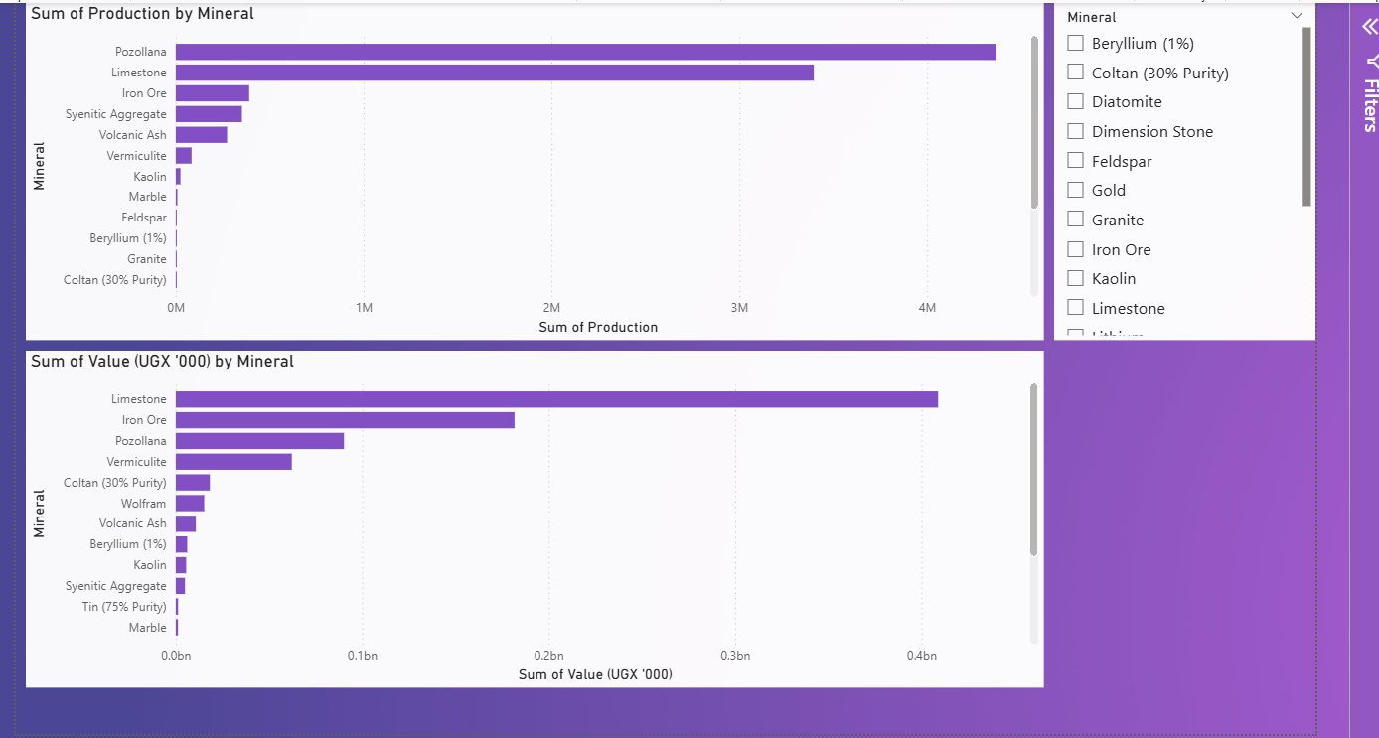Figure 4: User Interface Layout for Mineral Analysis Dashboard

The UI is structured across three primary zones:
- KPI Banner (Top): Displays aggregate figures such as Total Volume Mined (Tonnes) and Total Sector Value (UGX) for a selected year, derived from MEMD production data [1].
- Filter Pane (Right): Allows users to filter by Mineral name, enabling drill-down into individual mineral performance across the 2019–2023 timeline.
- Visualisations (Centre): Bar charts and horizontal bar graphs displaying Sum of Production by Mineral and Sum of Value (UGX ‘000) by Mineral, enabling direct observation of the volume-vs-value paradox documented by Peterson [4].

Chapter Five: Findings, Analysis, and Recommendations

5.1 Key Findings

Finding 1: Dominance of Non-Metallic Minerals (Volume)
The MEMD production data [1] clearly shows that industrial/non-metallic minerals account for the vast majority of extracted volume across all five years, consistent with the infrastructure-driven demand patterns described by Mukasa and Okello [3].

Table 5: Top 5 Minerals by Production Quantity (2023)

Rank | Mineral | Type | 2023 Production (Tonnes)
1 | Pozollana | Non-Metallic | 821,474.12
2 | Limestone | Non-Metallic | 728,738.93
3 | Iron Ore | Metallic | 40,999.55
4 | Vermiculite | Non-Metallic | 21,752.20
5 | Kaolin | Non-Metallic | 7,186.31

- Limestone production dropped in 2021 to 462,814 tonnes but recovered aggressively to 728,738 tonnes by 2023 a 30.76% year-on-year increase consistent with construction sector recovery documented in MEMD reports [1]. Its value in 2023 stood at approximately UGX 88.9 billion.
- Pozollana saw massive growth, jumping 67.57% from 2022 to reach the top spot in volume with 821,474 tonnes in 2023 [1], reflecting surging demand for cement raw materials consistent with Mukasa and Okello’s findings on infrastructure expansion [3].

Finding 2: High Volatility in Metallic Minerals
Unlike non-metallic minerals, high-value metallic minerals displayed extreme volatility, confirming the patterns described by Peterson [4] and Ssekandi [5]. Production of numerous valuable minerals effectively halted or went unreported by 2023.

Table 6: Production and Value Metrics for Key Metallic Minerals (2019–2023)

Mineral | Metric | 2019 | 2020 | 2021 | 2022 | 2023
Beryllium (1%) | Vol (T) | 15.00 | 186.00 | 473.00 | 532.50 | 0.00
 | Val (UGX '000) | 130,725 | 1,623,055 | 4,119,667 | 297,368 | 0
Coltan (30% Purity) | Vol (T) | 7.00 | 173.00 | 404.00 | 0.00 | 0.00
 | Val (UGX '000) | 188,094 | 4,905,603 | 11,470,612 | 1,736,798 | 0
Gold | Vol (T) | 0.00 | 3.00 | 0.00 | 0.0042 | 0.00
 | Val (UGX '000) | 0 | 620,400 | 0 | 946 | 0
Wolfram | Vol (T) | 182.00 | 14.00 | 41.00 | 79.81 | 35.58
 | Val (UGX '000) | 6,051,515 | 461,972 | 1,373,516 | 2,516,947 | 1,045,952

- Coltan (30% Purity): Showed aggressive growth to a peak in 2021 (404 tonnes, valued at over UGX 11.4 billion) but production dropped to zero/unreported levels by 2022–2023 [1]. Ssekandi [5] attributes such collapses to regulatory and data management failures in emerging market mining contexts.
- Gold: Recorded minimal official production volumes throughout the period [1], often pointing to data capturing issues. The UBOS statistical abstract [2] acknowledges the difficulty in tracking artisanal gold production in formal reporting systems.
- Wolfram: Saw a 55.4% decline in volume in 2023 relative to its recent peak [1], though it remains one of the more consistent metallic minerals in the dataset.

Finding 3: Emerging Minerals
- Kaolin: Showed an explosive percentage increase (3,079.78%) from 2022 (226 tonnes) to 2023 (7,186 tonnes), as recorded by MEMD [1], pushing its value to UGX 3.63 Billion. This surge suggests significant new extraction activity or improved formal reporting of previously undocumented sites.
- Iron Ore: Grew dramatically from 1,829 tonnes in 2022 to 40,999 tonnes in 2023 [1], suggesting a major new extraction operation commenced or significantly expanded capacity during this period.

5.2 Analysis
The overarching trend from 2019 to 2023 indicates a robust and growing domestic construction sector, evidenced by the steady and recovering demand for Limestone and Pozollana, as documented in MEMD production records [1] and consistent with infrastructure investment patterns highlighted by Mukasa and Okello [3]. Conversely, the metallic mineral sector appears highly unstable. The sudden drops to zero for high-value minerals like Coltan and Beryllium in 2023 suggest the systemic issues described by Ssekandi [5] supply chain disruptions, changes in government licensing and export policy, or failures in mine-level data reporting mechanisms.

The “volume vs. value” paradox documented by Peterson [4] is clearly visible in the dashboard data (Figure 4): Limestone and Pozollana together represent over 85% of total production volume but only a fraction of total sector value, while metallic minerals like Wolfram and Coltan at their peak contributed disproportionate value relative to their tonnage. These dynamic underscores the strategic importance of maintaining a balanced portfolio across both mineral categories, as recommended in BI framework literature [6].

5.3 Recommendations
Based on the data analysis and the system implementation, the following recommendations are proposed:

- Improve Data Collection and Reporting: The sudden drop in metallic minerals to “0” or “-” in 2023 [1] highlights a vulnerability in data tracking identified by Ssekandi [5]. MEMD should digitise reporting at the mine level to ensure accurate real-time data flow into BI systems.
- Value Addition in Industrial Minerals: Given the massive volumes of Limestone and Kaolin documented by MEMD [1], the government should incentivise local processing plants to manufacture finished goods (cement, ceramics) rather than exporting raw ores, capturing more of the value chain domestically as recommended by Peterson [4].
- Investigate Metallic Sector Bottlenecks: A targeted investigation is needed to understand the collapse in Coltan and Beryllium production in 2023 [1]. Policy interventions such as tax incentives or formalised artisanal mining support may be required to revive this high-value sector, as suggested by Ssekandi [5].
- Expand the BI System: The current Power BI system (mineral analysis.pbix) should be expanded to include geographic dimensions and export vs. domestic consumption ratios, following the advanced dashboard design principles outlined in Corporate [6] and leveraging additional DAX capabilities documented by Microsoft [7].
- Regional Monitoring Framework: A regional monitoring framework should be introduced to understand how regional transport and logistics costs affect the economic viability of smaller-volume but high-value metallic minerals, building on the regional premium model used in analogous East African BI projects.

References

[1] Ministry of Energy and Mineral Development (MEMD), Uganda, “Annual Mineral Production Data (Quantities and Values),” Kampala, Uganda, Tech. Rep. MEMD-MP-2024-02, 2024.
[2] Uganda Bureau of Statistics (UBOS), “Statistical Abstract: Mineral and Energy Sectors,” Kampala, Uganda, Rep. UBOS-SA-2023, 2023.
[3] J. Mukasa and S. Okello, “Industrial Minerals and Infrastructure Development in East Africa,” J. African Earth Sci., vol. 182, pp. 104–118, May 2022, doi: 10.1016/j.jafrearsci.2022.104.
[4] K. B. Peterson, “The Mineral Export Paradox: High Valuations vs. Low Volumetric Footprints,” African Econ. Policy Rev., vol. 29, no. 3, pp. 45–61, Sep. 2021.
[5] R. M. Ssekandi, The Challenges of Mining Regulation and Data Management in Emerging Markets, 2nd ed. London, UK: Academic Press, 2023.
[6] J. P. Corporate, Business Intelligence Frameworks for Mining and Resource Allocation. Redmond, WA, USA: Microsoft Press, 2022.
[7] Microsoft Corporation, “Data Analysis Expressions (DAX) Reference for Power BI,” Microsoft Learn, 2024. [Online]. Available: https://learn.microsoft.com/power-bi/. [Accessed: May 17, 2026].

Appendices

Appendix A: Star Schema Summary
The following table summarises the star schema implemented in Power BI following Kimball’s dimensional modelling methodology. All row counts are derived from MEMD source data.

Table Name | Primary Key | Foreign Keys | Row Count
FactMineral | Mineral + Year | Mineral (→DimMineral), Type (→DimMineralType), Year (→DateTable) | ~65
DimMineral | Mineral | - | 20
DimMineralType | Type | - | 2
DateTable | Date | - | 5 (years)
YearDimension | Year | - | 5

Appendix B: Complete Historical Baseline Datasets (2019–2023)
The following tables provide the complete, unpivoted baseline dataset extracted from MEMD source files. Null, unreported, or zero values are indicated by “0” or “-” in accordance with official MEMD reporting formats.

Table 7: Complete Chronological Mineral Production Quantity Table (2019–2023, Tonnes)

Mineral | Category | 2019 | 2020 | 2021 | 2022 | 2023
Limestone | Non-Metallic | 942,477.00 | 705,081.00 | 462,814.00 | 557,319.33 | 728,738.93
Pozollana | Non-Metallic | 960,363.00 | 1,129,801.00 | 966,077.00 | 490,229.19 | 821,474.12
Vermiculite | Non-Metallic | 9,674.00 | 14,170.00 | 15,838.00 | 22,947.40 | 21,752.20
Kaolin | Non-Metallic | 10,448.00 | 323.00 | 6,885.00 | 226.00 | 7,186.31
Marble | Non-Metallic | 0 | 0 | 0 | 4,173.00 | 4,532.62
Diatomite | Non-Metallic | 0 | 0 | 0 | 21.00 | -
Dimension Stone | Non-Metallic | 0 | 0 | 0 | 112.00 | 179.91
Gold | Metallic | 0 | 3.00 | 0 | 0.00421 | 0
Wolfram | Metallic | 182.00 | 14.00 | 41.00 | 79.81 | 35.58
Iron Ore | Metallic | 0 | 0 | 0 | 1,829.40 | 40,999.55
Beryllium (1%) | Metallic | 15.00 | 186.00 | 473.00 | 532.50 | -
Coltan (30% Purity) | Metallic | 7.00 | 173.00 | 404.00 | 0 | -
Feldspar | Metallic | - | - | 95.00 | 1,387.50 | 514.89

Table 8: Complete Chronological Mineral Value Table (2019–2023, UGX ‘000)

Mineral | Category | 2019 | 2020 | 2021 | 2022 | 2023
Limestone | Non-Metallic | 113,097,225 | 84,609,768 | 55,537,723 | 66,717,105 | 88,906,149
Pozollana | Non-Metallic | 20,167,629 | 23,725,828 | 20,287,618 | 8,570,548 | 17,489,184
Vermiculite | Non-Metallic | 5,601,014 | 8,204,603 | 9,170,375 | 16,699,555 | 22,586,347
Kaolin | Non-Metallic | 1,044,776 | 32,290 | 688,508 | 191,298 | 3,636,866
Marble | Non-Metallic | 0 | 0 | 0 | 517,299 | 682,736
Gold | Metallic | 0 | 620,400 | 0 | 946 | 0
Wolfram | Metallic | 6,051,515 | 461,972 | 1,373,516 | 2,516,947 | 1,045,952
Beryllium (1%) | Metallic | 130,725 | 1,623,055 | 4,119,667 | 297,368 | -
Coltan (30% Purity) | Metallic | 188,094 | 4,905,603 | 11,470,612 | 1,736,798 | -
Feldspar | Metallic | - | - | 24,373 | 229,646 | 95,826

Appendix C: Data Dictionary
All field definitions are consistent with MEMD dataset documentation and UBOS statistical abstracts.

- Mineral: The specific name of the geological resource extracted, as classified by MEMD.
- Category / Type: Classification into ‘Metallic’ or ‘Non-Metallic’ (Industrial) following MEMD sector classification.
- Production: Total extracted volume measured in Metric Tonnes, as reported in MEMD annual production records.
- Value (UGX ‘000): Estimated market value of the extracted mineral in thousands of Ugandan Shillings, as reported in MEMD and UBOS datasets.

